SALESGENIE: FIND A BUSINESS
You can search by Company name or Phone Number to look up potential prospects to get more information on their company. Click Search for Leads, then US Business and enter the fields you wish to search with:
*Remember, sometimes less is more and sometimes partial names or phone numbers can help pull the information
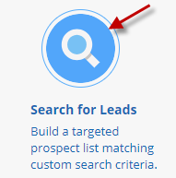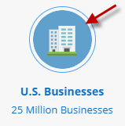
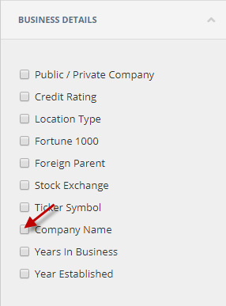
AND/OR
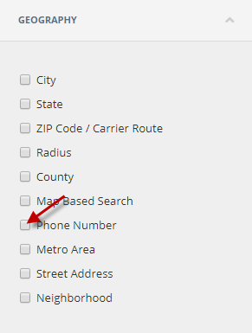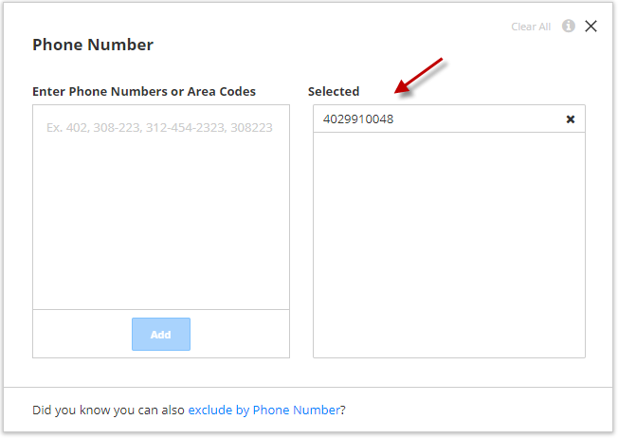
Once you’ve pulled up a record you were trying to find, you have the ability to double click on the business name to view the company profile page or click Details at the top right.
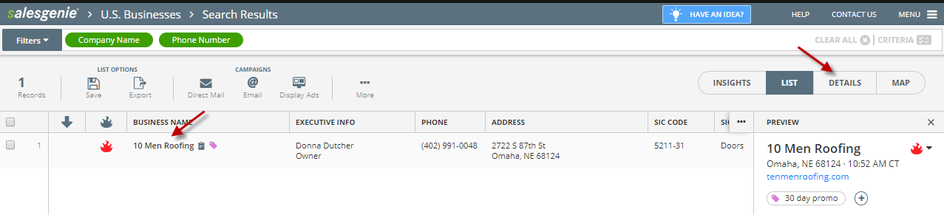
From here you’ll see detailed information about the company, be able to view the record on a map, as well as Find Similar Businesses like this one or Nearby Businesses in the area.
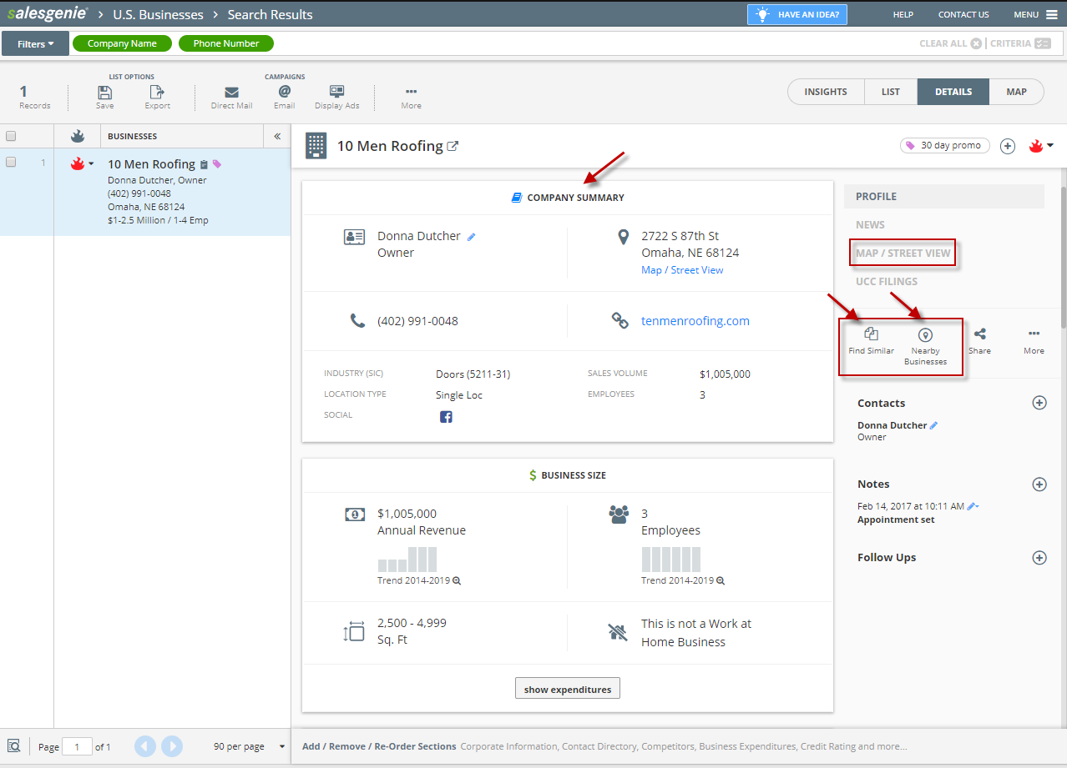

Find Similar will allow you to run a new search based on the main attributes of this company. You can uncheck or change the State you run the new search in from the attributes showing:
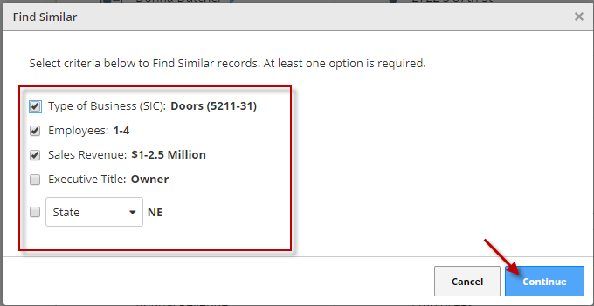
By clicking Continue, you then have a new search based on the attributes above:
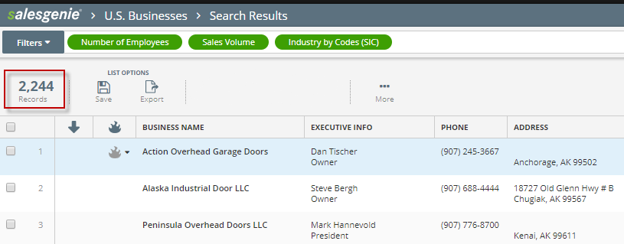
Nearby Businesses will pull up a map allowing you to Draw a Shape or Define Radius around this company for other businesses in the area. This feature is great if you will be out in the field to contact other companies.
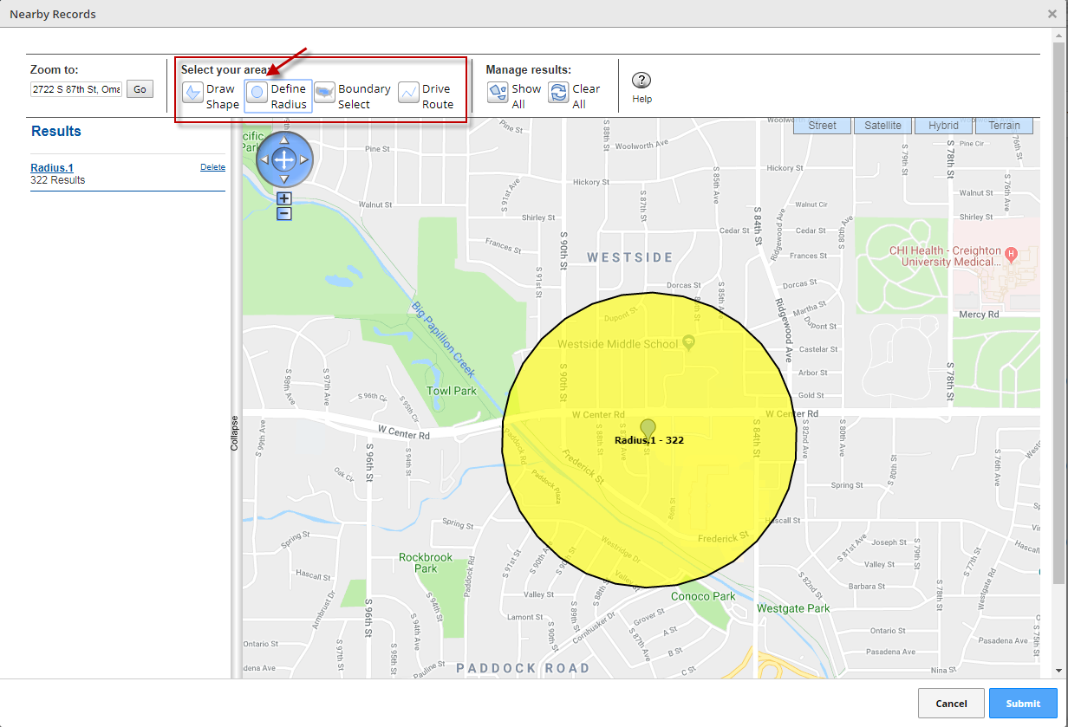
By clicking Submit, you now have a new list of businesses within the radius you created around that company. From here you can click on Filters to select additional criteria.
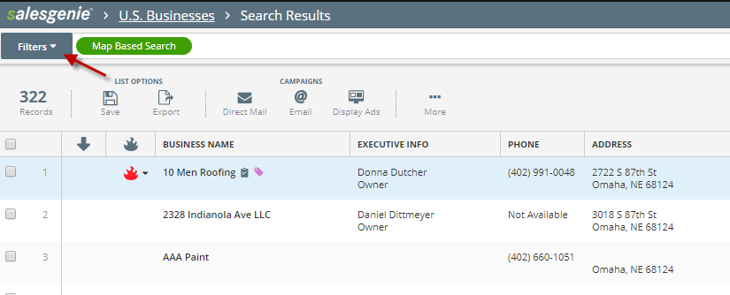
For additional guides or trainings you can visit our Aflac Salesgenie Microsite here: https://www.salesgenie.com/AFLAC/
You can also reach our Aflac rep and customer service team:
Maren Muldoon
Toll free: 866.873.9069
maren.muldoon@infogroup.com
aflachelp@salesgenie.com

