SALESGENIE US BUSINESS GUIDE
*Aflac sends us approximately 3.5 million records of current Aflac customers and internal Aflac do not contacts to suppress within Salesgenie so you don’t have to worry about prospecting to existing customers – if you do come across a current customer however, simply let us know so can verify with Aflac to aflachelp@salesgenie.com
To build a prospect list within Salesgenie, click on Search for Leads, then US Business to build a list
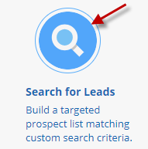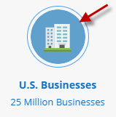
Select your Geography:
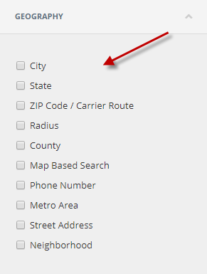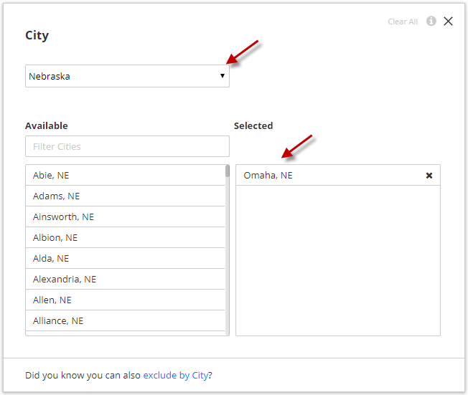
Select your employee size you are looking for – you can choose either employee size ranges, OR type in the exact employee size you are looking to target (DO NOT SELECT BOTH):
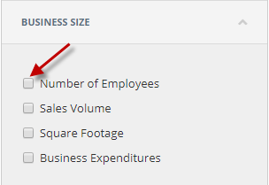
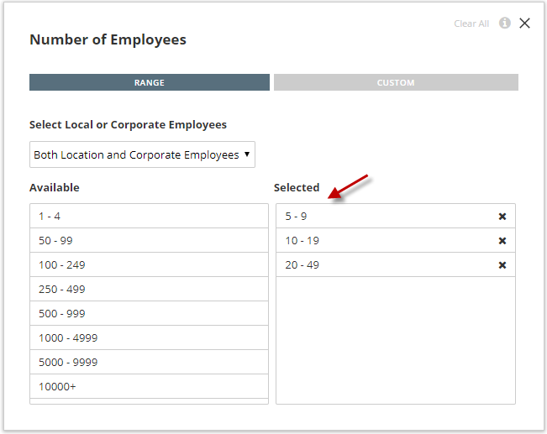
OR
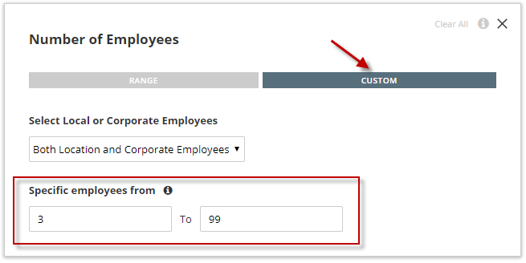
You can next select the Location Type of companies you wish to target
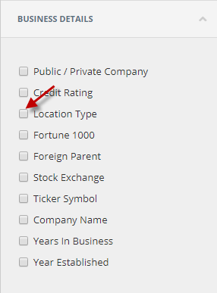
You also have the option to include/exclude Home Based Businesses as well as remove duplicate contacts per company location to avoid duplicate records for the same company in your search using the Professionals filter
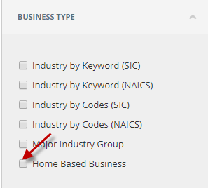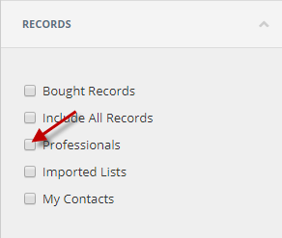

Once you’ve selected all filters you wish to target, click Run Search to view the list
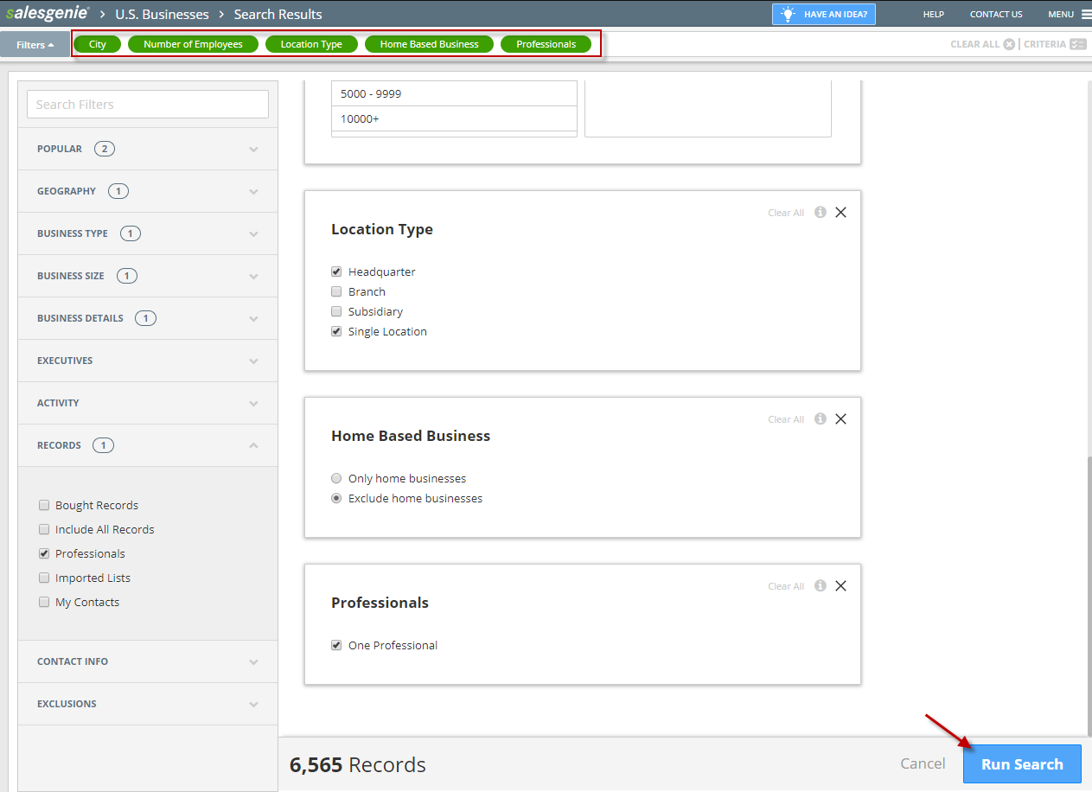
SAVE YOUR SEARCH. This saves the list within your Salesgenie account on your Home page so you can easily open the list back up or see what criteria you ran the search with in the future.
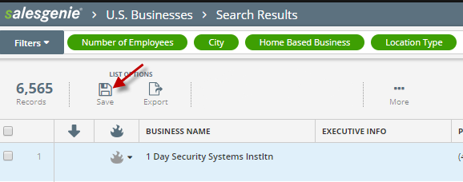
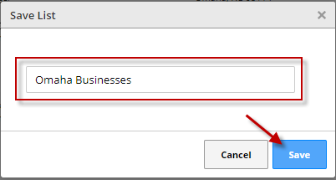 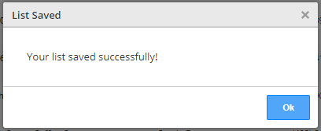
Now you will see your list name at the top of your list and the number of records, as well as on your Home page of Salesgenie:
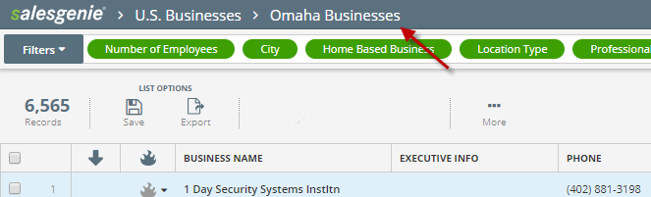
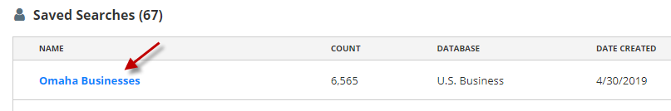
Now that you have your list saved, you will have access to this Saved Search on the Salesgenie Mobile App as well when you are out at appointments to view. The Salesgenie App is FREE to download on both Android and IPhones through the app stores.
Once installed, log into the Salesgenie app using your Salesgenie username & password (same as for the Salesgenie website):
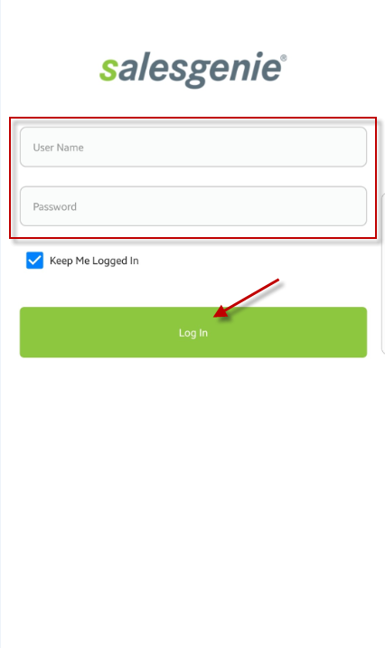
Once logged in, click on the My Saved Searches button to access the saved searches you’ve done within the Salesgenie website.
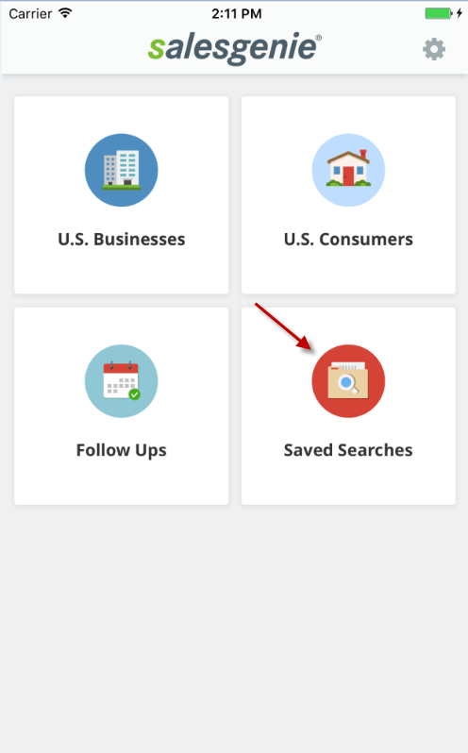 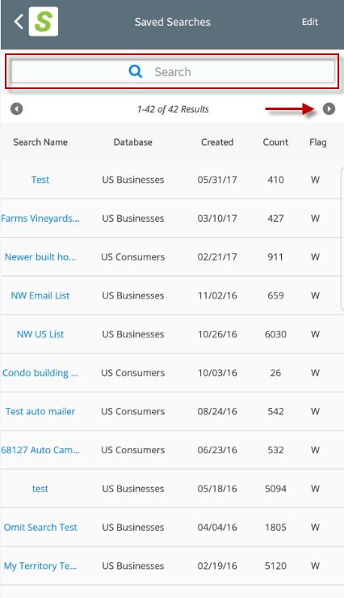
For additional guides or trainings you can visit our Aflac Salesgenie Microsite here: https://www.salesgenie.com/AFLAC/
You can also reach our Aflac rep and customer service team:
Maren Muldoon
Toll free: 866.873.9069
maren.muldoon@infogroup.com
aflachelp@salesgenie.com

