Dynamics user script

Setting up your Salesgenie account in Dynamics is easy; just follow to these simple steps.
Step 1
- Click “Settings”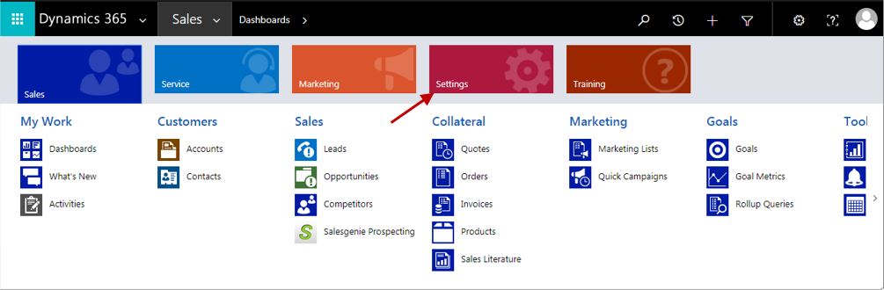
Step 2
- Then click “Salesgenie Credentials”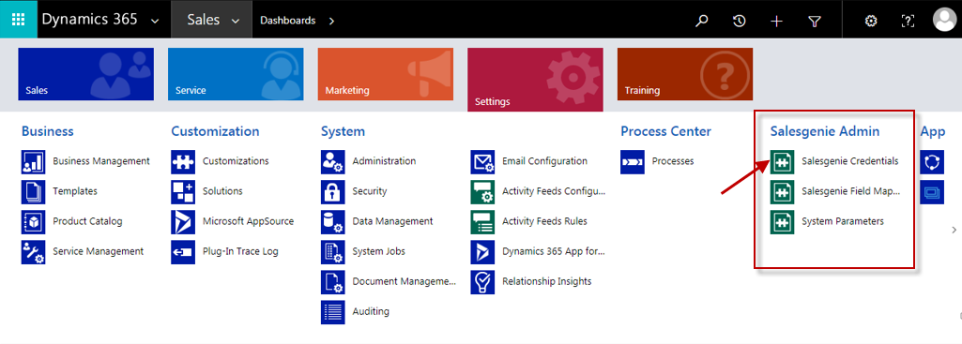
Step 3
- Then click “New”
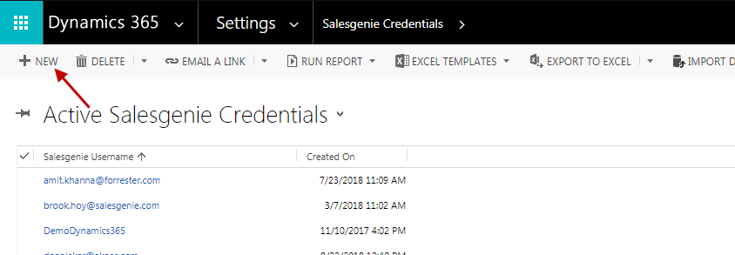

Step 4
- Enter your Salesgenie username and password
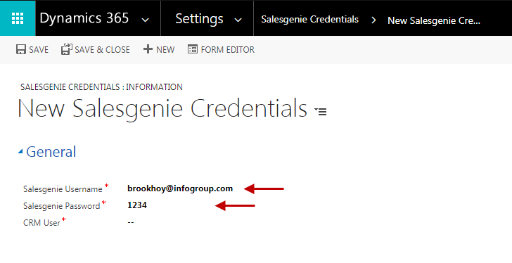
Step 5
- Assign your CRM username
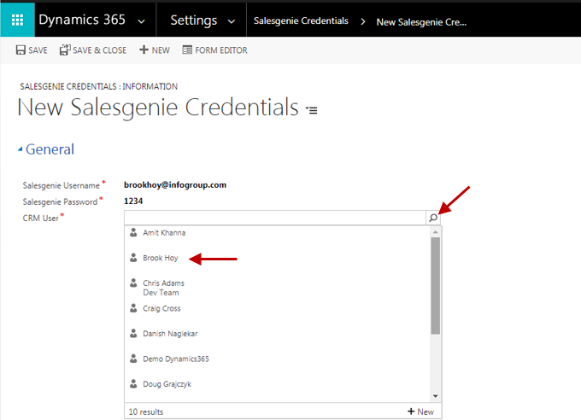

Step 6
- Click “Save”
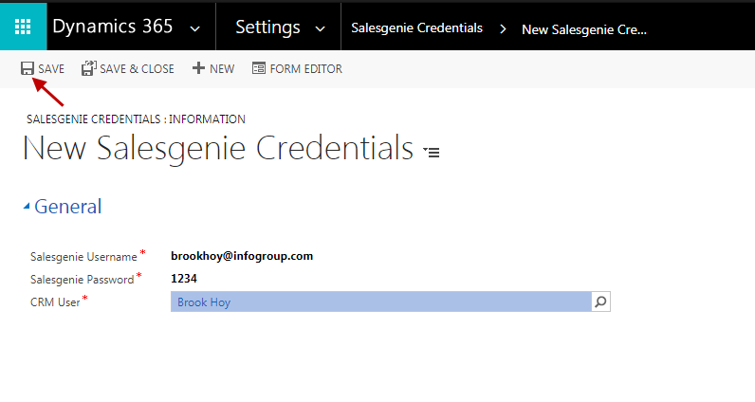
How to use SG within Dynamics
- Now to access Salesgenie just click your Sales tab and look for the Salesgenie Prospecting icon under the Sales section.
- This will get you access to Salesgenie.
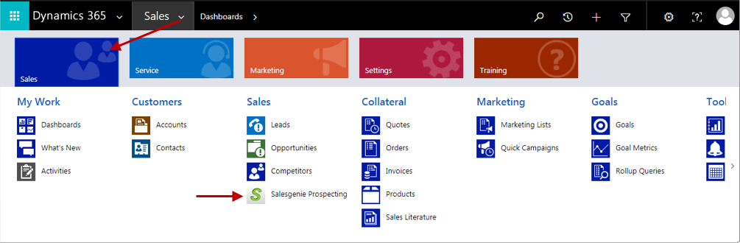
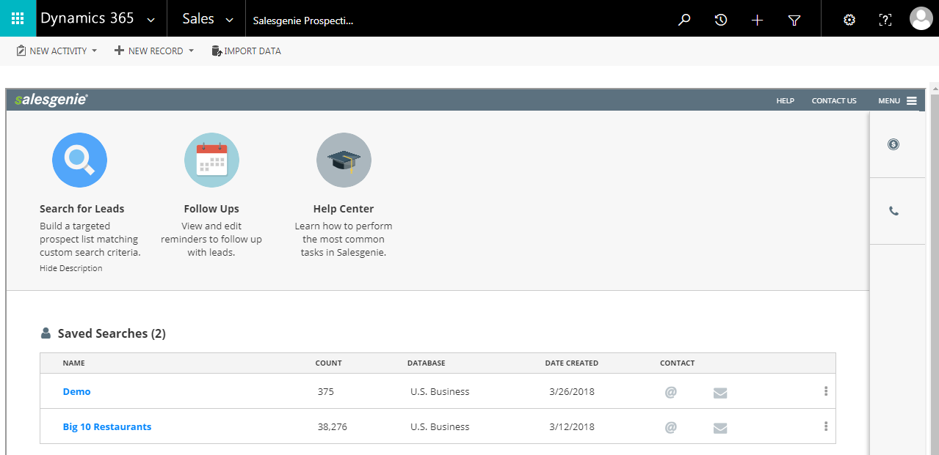

Exporting records
- To export leads into Dynamics look for the available export options
- Once you’re ready to export just select the “Export to Dynamics CRM” option
- You can export one or multiple leads at a time
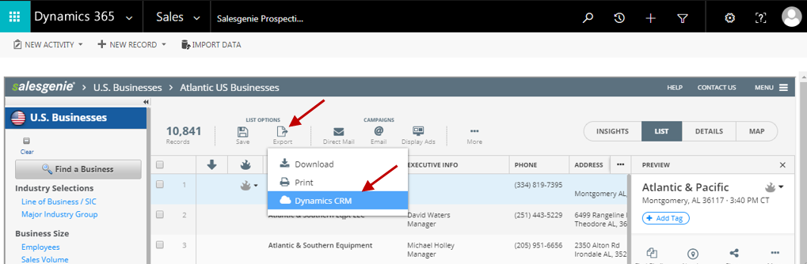
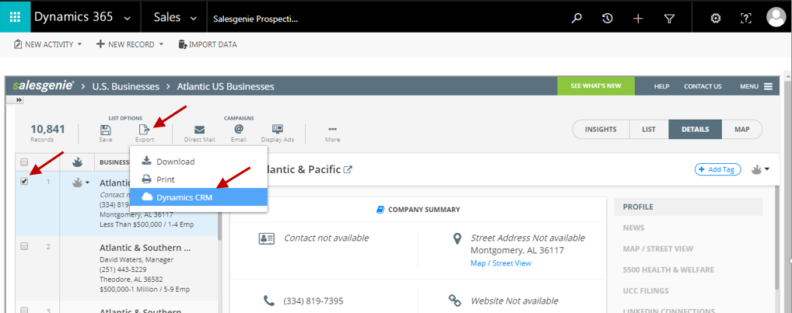|
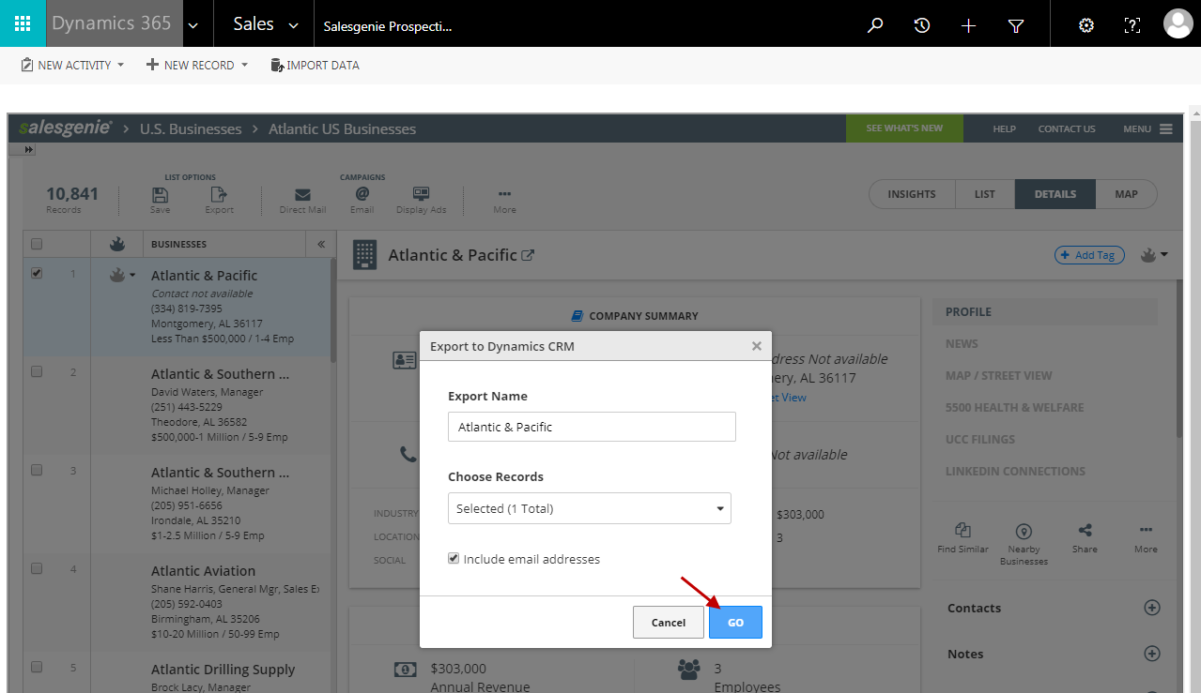
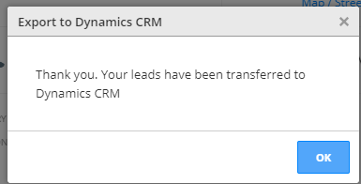
Salesgenie leads in Dynamics
- Your Salesgenie leads can be found by selecting the Leads icon under the Sales section
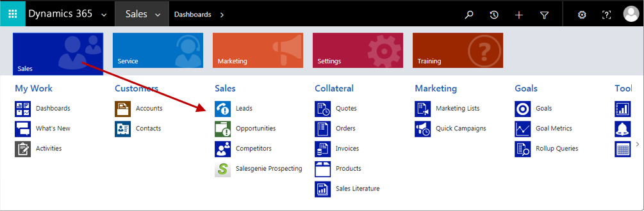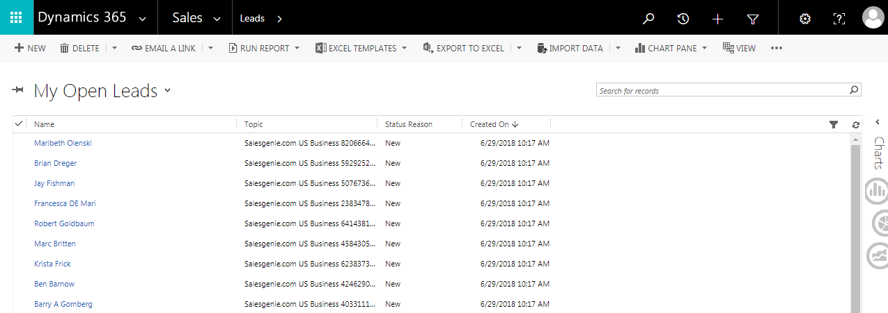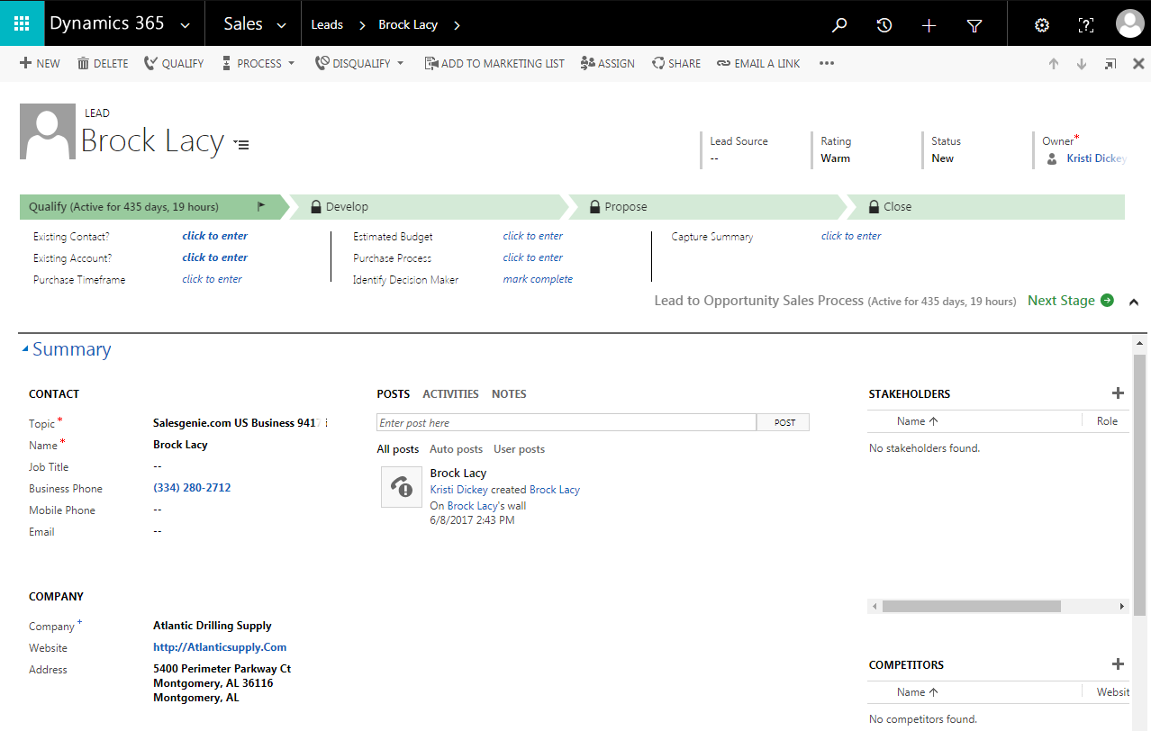

Salesgenie mobile app
- And don’t forget you can export leads from your Salesgenie mobile app to Dynamics too
